**Software Requirements and Design Document**

**For**

**Group <5>**

Version 1.0

**Authors**:

Matthew Christoffel  
 Alan Castillo

Kirsten Blair

Writer Leto

Alexander Kajada

# **1.** **Overview (5 points)**

*Give a general overview of the system in 1-2 paragraphs (similar to the one in the project proposal).*

*We are creating a tech news blog site. It will be a web application where people will post tech news stories with a link and brief description. There is no authentication at the moment so all users are able to visit the site and add, update, delete, like, dislike posts to the database. We are using Python, Flask, SQLAlchemy, HTML, and CSS to create the app.*

# **2.** **Functional Requirements (10 points)**

*List the* ***functional requirements*** *in sentences identified by numbers and for each requirement state if it is of high, medium, or low priority. Each functional requirement is something that the system shall do. Include all the details required such that there can be no misinterpretations of the requirements when read. Be very specific about what the system needs to do (not how, just what). You may provide a brief design rationale for any requirement which you feel requires explanation for how and/or why the requirement was derived.*

1) Posting Functionality

◦ Users should be able to post links to articles with a title, description, and URL - High

◦ Each post should allow users to leave comments, like, dislike. -medium

◦ Users should be able to update their own posts.

2) User Registration and Authentication

◦ Users should be able to register using their google account

◦ Users should be able to log in via a login page.

3) User Profile Management

◦ Users should have profiles where they can manage their information and set site

preferences.

◦ Username, email, google account picture, and a user post history should be visible.

4) Admin Content Moderation

· Admin accounts should be able to delete posts.

· Admin accounts should be able to delete users from the system.

5) Search and Filtering

◦ Users should be able to search for posts based on title.

◦ Users should be able to filter categories of posts.

# **3.** **Non-functional Requirements (10 points)**

*List the* ***non-functional requirements*** *of the system (any requirement referring to a property of the system, such as security, safety, software quality, performance, reliability, etc.) You may provide a brief rationale for any requirement which you feel requires explanation as to how and/or why the requirement was derived.*

1. Performance
   * The website should respond within 3 seconds of receiving user interaction.
2. Usability
   * The user interface should be intuitive and easy to navigate, with clear labeling and consistent design patterns.
3. Maintainability
   * The codebase should be well-structured and modular, following best practices for software development.
   * Documentation should be comprehensive and up-to-date
4. Performance Monitoring and Logging
   * The system should log performance metrics and errors.
5. Security
   * The website should have working systems that secure sensitive data from unauthorized access.
   * User data should be encrypted to prevent unauthorized access and ensure data safety

# **4.** **Use Case Diagram (10 points)**

*This section presents the* ***use case diagram*** *and the* ***textual descriptions*** *of the use cases for the system under development. The use case diagram should contain all the use cases and relationships between them needed to describe the functionality to be developed. If you discover new use cases between two increments, update the diagram for your future increments.*

***Textual descriptions of use cases****: For the first increment, the textual descriptions for the use cases are not required. However, the textual descriptions for all use cases discovered for your system are required for the second and third iterations.*

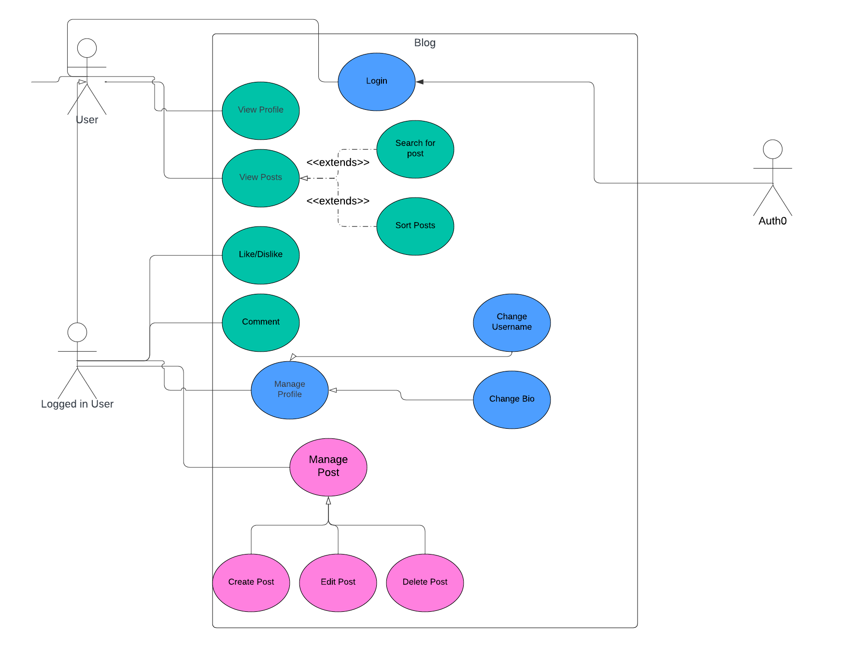

# **5.** **Class Diagram and/or Sequence Diagrams (15 points)**

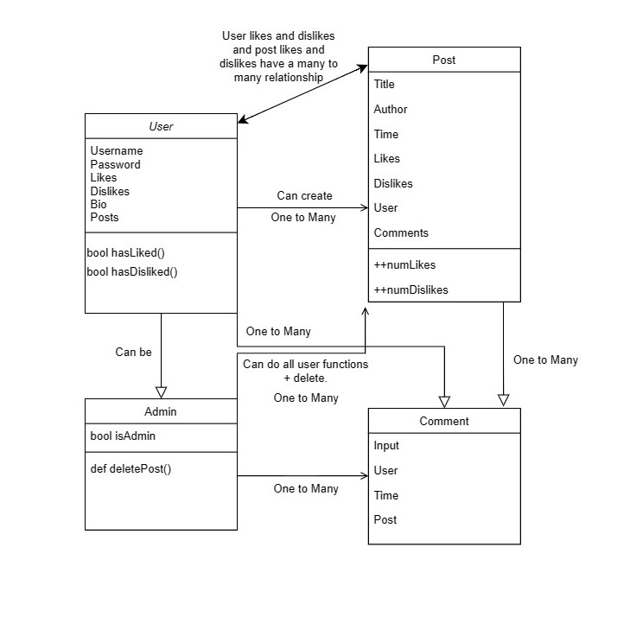

*Sequence Diagram for a User creating a Post*

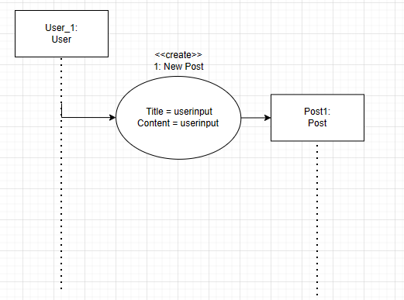

*Sequence Diagram for a User creating a Comment on a Post*

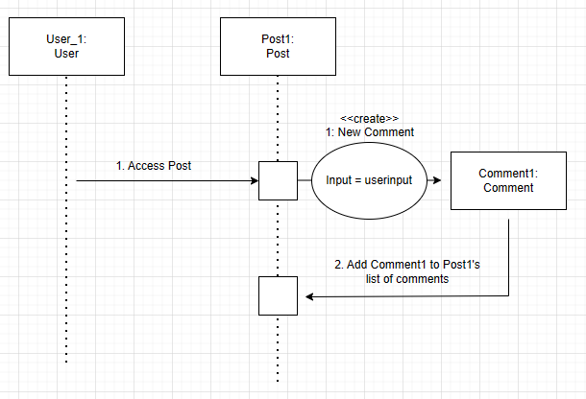

*Sequence Diagram for an Admin deleting a Post and its Comments*

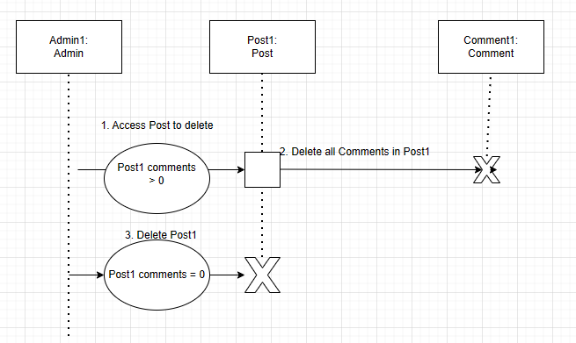

*If the main* ***paradigm*** *used in your project is* ***Object Oriented*** *(i.e., you have classes or something that acts similar to classes in your system), then draw the* ***Class Diagram******of the entire system and Sequence Diagrams for the three (3) most important use cases in your system.***

*A* ***Sequence Diagram*** *simply depicts* ***interaction******between objects*** *(or* ***functions -*** *in our case - for non-OOP systems) in a sequential order, i.e. the order in which these interactions take place. Sequence diagrams describe how and in what order the objects in a system function.*

# **6.** **Operating Environment (5 points)**

*Describe the environment in which the software will operate, including the hardware platform, operating system and versions, and any other software components or applications with which it must peacefully coexist.*

The platform of the web application will be a hosted web server accessible by any common web browsers such as Google Chrome or Firefox. The development environment will be operated using Visual Studio Code and stored on the Git repository.

# **7.** **Assumptions and Dependencies (5 points)**

*List any assumed factors (as opposed to known facts) that could affect the requirements stated in this document. These could include third-party or commercial components that you plan to use, issues around the development or operating environment, or constraints. The project could be affected if these assumptions are incorrect, are not shared, or change. Also identify any dependencies the project has on external factors, such as software components that you intend to reuse from another project.*

The web application will depend on third party APIs and libraries for the software’s functions. The hosting server will use nginx, gunicorn, certbot, and lynis. Auth0 will be used to allow users to signup and login to the site. SQLAlchemy will be used to create and store the database for user posts. The content moderation requirements will assume a team of admins will be doing moderation manually, rather than an automated moderation system.The Search and Filtering systems may assume that users input correct post categories or titles so they can be easily searched for.